oVirt bug workaround
There is a bug in ovirt 3.5 which prevents a vm from booting. This document will explain how can can solve this issue.
- Go to the vm that wont boot
- Right click edit
- Click on “show advanced options”
- Go to host and copy below settings:
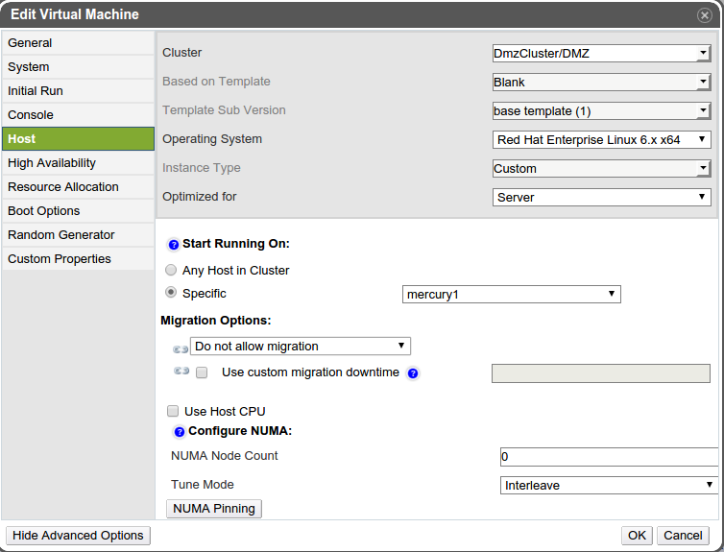
- Click on ok
- Right click again on the vm edit
- Go to the host tab again and copy below settings:
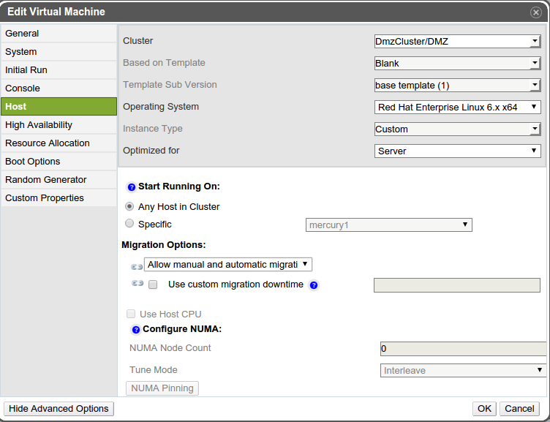
- Click on ok.
- You can start your vm again

